2nd International Workshop on
“Digital and Sustainable Practices for Cultural Heritage”
June 2026 – July 2026 | Online
Invitation
The HI-EURECA-PRO team is pleased to announce the launch of the 2nd International Workshop on Digital and Sustainable Practices for Cultural Heritage, organised by the Renewable and Sustainable Energy Systems Lab (ReSEL@TUC) and the Transformable Intelligent Environments Laboratory (TIE Lab).

The second cycle will take place from 23 June 2026 to 03 July 2026, offering a structured two-week programme of focused sessions designed to equip participants with the latest knowledge and practical skills at the intersection of digital innovation and sustainability in cultural heritage.

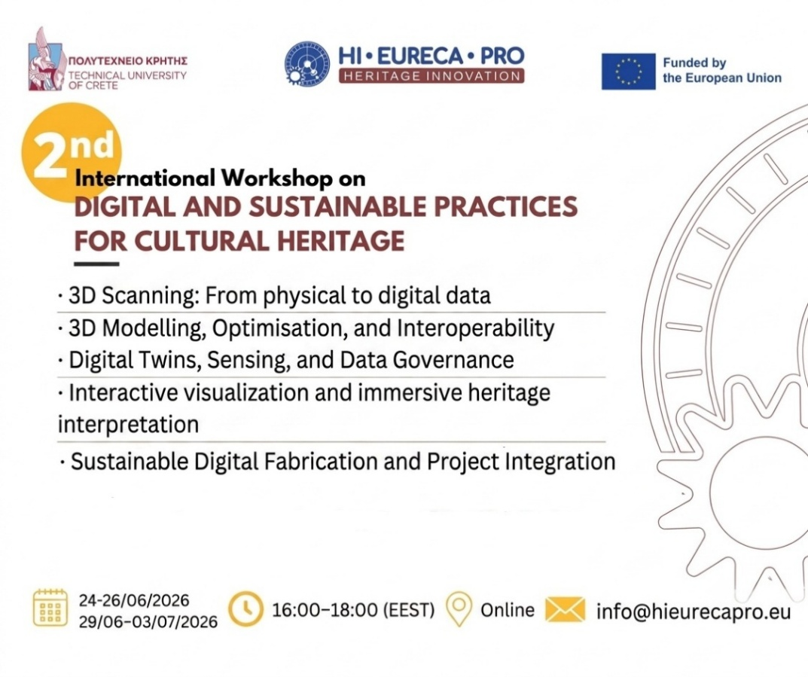
Participating in this workshop series offers a unique opportunity to gain cutting-edge knowledge and practical skills in digital documentation and analysis of cultural heritage assets. It will enhance your understanding of the most up-to-date digital and sustainable practices for cultural heritage (digital twins, AI, sensing, etc) and strengthen international collaboration through the exchange of best practices. Ultimately, the series contributes to the broader European digital and green transition within the heritage sector.

Whether you're a researcher, technology transfer officer, policymaker, or heritage professional, this workshop will empower you to contribute to a greener, more resilient future for cultural heritage.

REGISTER NOW for the 2-week programme!

🔎 Workshop Information
- Title: 2nd International Workshop on Digital and Sustainable Practices for Cultural Heritage
- Dates: June 2026 (last week) – July 2026 (first week)
- Time: 16:00–18:00 (EET, Athens time)
- Format: Online
- Language: English

📚 Program

Week 1 (24-26/06/2026)
Day 1 - Captured
3D Scanning: From physical to digital data
Day 2 - Structured
3D Modelling, Optimisation, and Interoperability: From raw scan to reusable digital asset

Week 2 (29/06–03/07/2026)
Day 3 - Live
Digital Twins, Sensing, and Data Governance: From static model to data-responsive system
Day 4 - Experienced
Interactive visualization and immersive heritage interpretation: Navigable Unity scene with heritage model
Day 5 - Materialised
Sustainable Digital Fabrication and Project Integration: From digital model to physical or hybrid output

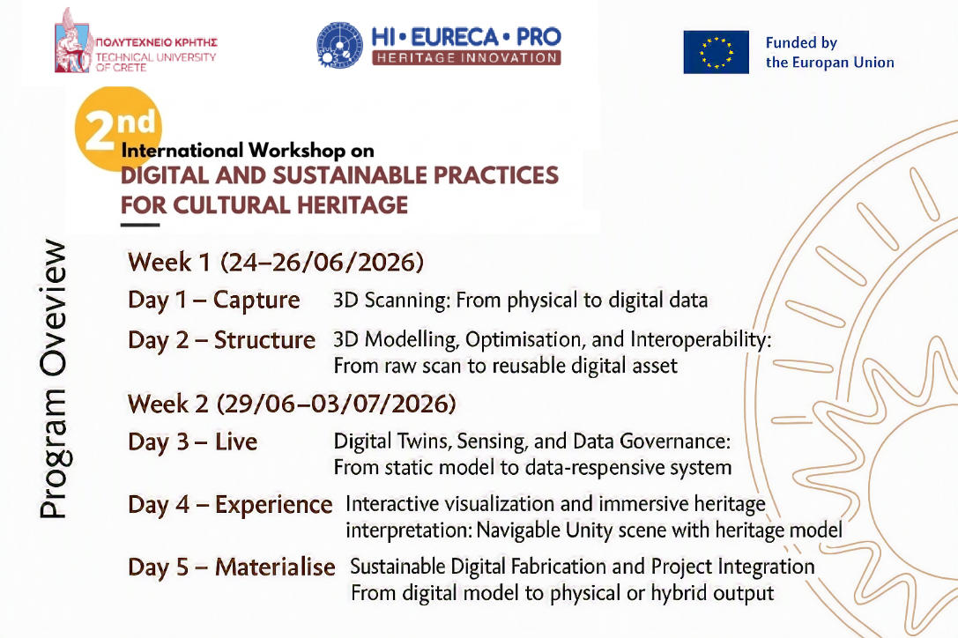

📝Registration
Participants should register using the Participation Form to secure their participation and receive information and an access code. We look forward to your participation in this significant dialogue on digital innovation and sustainability in cultural heritage.

